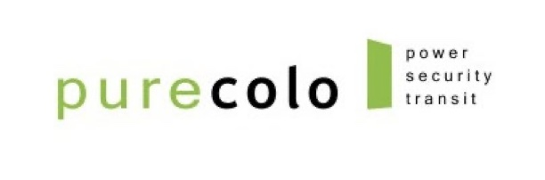

ACCEPTABLE USE POLICY (AUP)

Effective Date: [●], 2026

Applies To: All customers, users, contractors, and visitors using PureColo’s facilities, network, and services (“Users”).

- Purpose
This Acceptable Use Policy (“AUP”) ensures the security, reliability, and lawful use of PureColo’s data center and network infrastructure. All Users must comply with this AUP as a condition of accessing or using any PureColo Data Center services.

- Scope
This AUP applies to all services provided by PureColo Inc. (“PureColo”), including colocation, cross-connects, Internet access, power, and any managed or network-related services, as well as physical access to PureColo facilities.

- Customer Responsibility
Each Customer is responsible for ensuring compliance with this AUP by all of its users, employees, contractors, and vendors. Customers must maintain the security and integrity of their own systems and data and prevent unauthorized access, transmission, or storage of harmful or illegal content.

- Prohibited Uses
Users shall not use PureColo’s Services or Facility to:

- Violate any local, provincial, state, federal, or international law or regulation.
- Engage in fraud, theft, money laundering, or dissemination of illegal materials.
- Store, transmit, or host child exploitation material, hate speech, or unlawful content.
- Interfere with, disrupt, or damage the network or systems of PureColo or any other customer.
- Launch or participate in denial-of-service (DoS/DDoS) attacks, port scanning, or similar intrusive activities.
- Circumvent security controls, firewall rules, or authentication mechanisms.
- Send spam, unsolicited bulk emails, or other forms of abusive communications.
- Forge headers, addresses, or identities for deceptive purposes.
- Attempt to gain unauthorized access to any system, data, or network.
- Introduce viruses, worms, ransomware, or other malicious code.
- Tamper with monitoring systems, security cameras, sensors, or access controls.
- Access restricted areas without authorization or damage Facility equipment or cabling.
- Bring prohibited materials into the Facility, including weapons, explosives, or hazardous substances.

- Network and System Security
PureColo reserves the right to take any reasonable action to protect its infrastructure, including filtering or blocking harmful traffic, suspending or limiting Services during a security event, and cooperating with law enforcement or affected third parties.

- Reporting Violations
Suspected violations of this AUP should be reported immediately to abuse@purecolo.com. PureColo may investigate any reported breach and will cooperate with law enforcement as required.

- Enforcement
Violations of this AUP may result in immediate suspension or termination of Services, revocation of Facility access, legal action where applicable, and recovery of costs incurred by PureColo to address or mitigate the violation. PureColo determines in its sole discretion what constitutes a violation of this AUP.

- Updates
PureColo may amend this AUP from time to time. The most current version will always be available at [https://purecolo.com/legal/].

